Steps to use:

1. Click on "[calculation](https://www.pythonanywhere.com/user/shreyajoshi/files/home/shreyajoshi/Calculation.py?edit)” link and you should be able to see the below screen.

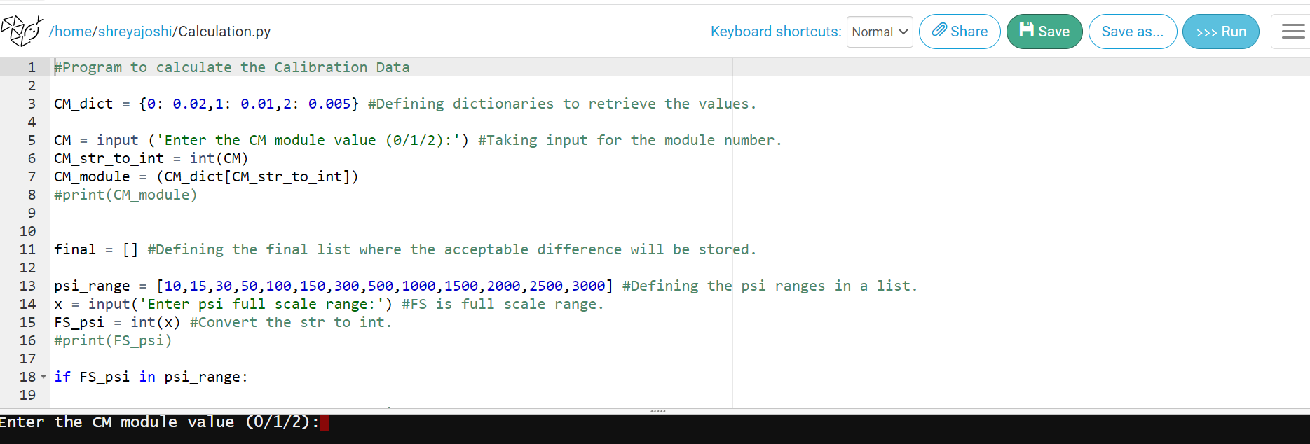

>>run

1. Click on “run’ as highlighted below in red.



1. You should be able to see the “CM module input” in the console as highlighted below.

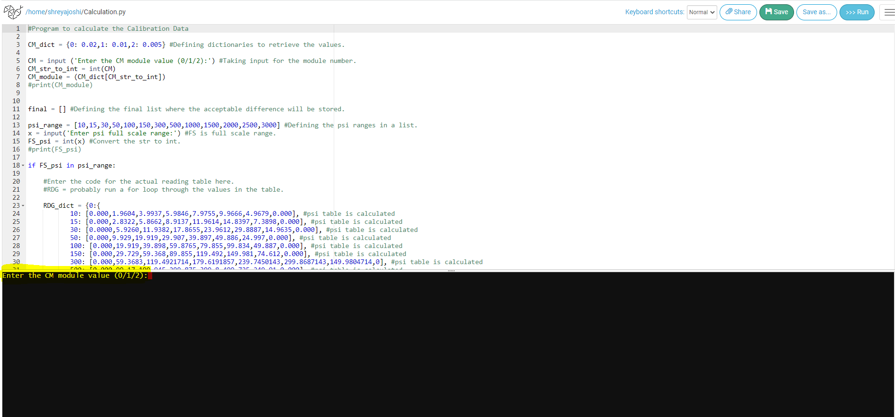

1. Once you enter CM module value, hit enter, then enter psi full scale range, and hit enter. You should be able to see the calculated ranges.

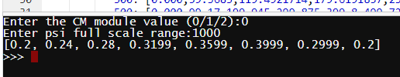

1. Hit “run” again to begin with the next calculation and follow step 1 onwards.